BACKGROUND
- Are you a visitor/tourist?
  - No
  - Work-related visitor
  - Leisure-related visitor
  - Other: ______________________________
- In minutes, how long does it take to walk from your home/where you’re staying to the closest [SYSTEM NAME] station?
________ minutes
  - I live/am staying outside the system area
  - Don’t know/not sure
- In minutes, how long does it take to walk from your main place of work/school to the closest [SYSTEM NAME] station? (Surveyor Instructions: If person is a work-related visitor, ask about main work place while here.)
________ minutes
  - I work outside the system area
  - N/A (unemployed/travels to multiple work places equally/leisure visitor)
  - Don’t know/not sure
- How do you get around on a regular basis? List all the different transportation modes you use frequently. Include how you get to and from work but not special or very infrequent trips.
  - Bus
  - [BRT]
  - [URBAN RAIL – subway, light rail, streetcar]
  - [COMMUTER/REGIONAL RAIL]
  - Car
  - Carshare, e.g. Zipcar, car2go
  - Taxi/Lyft/Uber etc.
  - Walk
  - Personal Bike
  - Bike Share
  - Other: ______________________________

- Do you have any of the following vehicles available to you on a regular basis to get around? Choose all that apply. (Surveyor Instructions: Read all responses.)
  - Personal bike (other than [SYSTEM NAME])
  - Bike Share (Monthly or Annual Membership)
  - Carshare, e.g. Zipcar, car2go
  - Car, van, SUV, truck or other personal vehicle
  - Other: ______________________________
- What type of [SYSTEM NAME] membership or pass did you use for this trip?
  - (List all membership and pass types as they differ by duration or usage scheme, but not cost or payment method. See ‘Model Responses for System-Specific Questions’ at end of section for models.)
- Is the pass or membership you used reduced cost or discounted? This includes things such as subsidized plans, reduced cost plans provided by your employer, or free passes. (Surveyor Instructions: Probe for more specificity if not adequate.)
  - (List all types of discounts for the system that are of interest, including income-/public-housing-based, corporate discounts, free passes through promotions or hotels etc. See ‘Model Responses for System-Specific Questions’ at end of section for models.)
- How did you pay for the membership or pass you used for this trip? For example, cash, credit/debit, or with your phone.
  - Cash
  - Credit/Debit
  - Phone
  - Other: ______________________________

RIDER BEHAVIOR

GENERAL
Skip any questions in this section (Q9 – Q15) if respondent is a visitor/tourist

Bike Share Only
- As a result of using [SYSTEM NAME], how much more or less often do you ride a bicycle? This includes both [SYSTEM NAME] and any personal bicycle.
  - Much more often
  - Somewhat more often
  - About the same
  - Somewhat less often
  - Much less often
- As a result of using [SYSTEM NAME], how much more or less often do you use each of the following transportation modes?
 | Much less often | Somewhat less often | About the same | Somewhat more often | Much more often | N/A or never used
Bus
[BRT]
[URBAN RAIL – subway, light rail, streetcar]
[COMMUTER/REGIONAL RAIL]
Car
Carshare, e.g. Zipcar, car2go
Taxi/Lyft/Uber etc.
Walk
Personal Bike
Other:

- In a typical month at this time of year, how many times do you take [SYSTEM NAME] for a trip where you would’ve previously used a different transportation mode, including walking?
- Never
- Once a month or less
- A few times a month
- About once a week
- 2 - 4 times a week
- 5 + times a week
- Don’t know/not sure

Personal Bike Also
- If you didn’t have access to [a bike/SYSTEM NAME], what transportation mode would you most often replace [your bike/SYSTEM NAME] trips with?
  - Bus
  - [BRT]
  - [URBAN RAIL – subway, light rail, streetcar]
  - [COMMUTER/REGIONAL RAIL]
  - Car
  - Carshare, e.g. Zipcar, car2go
  - Taxi/Lyft/Uber etc.
  - Walk
  - Personal Bike
  - Bike Share
  - Other: ______________________________
- In a typical month at this time of year, how often do you use [a bike/SYSTEM NAME] to get to or from the following transportation modes?
 | Never | Once a month or less | A few times a month | About once a week | 2 – 4 times a week | 5 + times a week | Don’t know/not sure
Bus
[BRT]
[URBAN RAIL – subway, light rail, streetcar]
[COMMUTER/REGIONAL RAIL]
Car
Carshare, e.g. Zipcar, car2go
Other:

- In a typical month at this time of year, how often do you make a round trip where you take [a bike/SYSTEM NAME] in one direction and the following transportation modes in the other direction?
 | Never | Once a month or less | A few times a month | About once a week | 2 – 4 times a week | 5 + times a week | Don’t know/not sure
Bus
[BRT]
[URBAN RAIL – subway, light rail, streetcar]
[COMMUTER/REGIONAL RAIL]
Car
Carshare, e.g. Zipcar, car2go
Taxi/Lyft/Uber etc.
Walk
Other:

- What have you or do you use [a bike/SYSTEM NAME] for? (Surveyor Instructions: Don’t read options at first, but check those similar to respondent’s answers. If respondent is confused, responses can be read.)
  - Go to/from work
  - Go to/from school
  - Errands/appointments
  - Social activities/dining/shopping
  - Exercise/recreation
  - Work meeting/appointment
  - Get to or from train/bus
  - Other: ______________________________

SPECIFIC TRIP

Bike Share Only
- (Please indicate how strongly you agree or disagree with the following statement) The availability of a [SYSTEM NAME] station influenced my decision to come to this area today.
  - Strongly Agree
  - Agree
  - Disagree
  - Strongly Disagree
  - Neutral/No Opinion
- What [SYSTEM NAME] station did the trip you just took start at? Please give the closest intersection (A park or landmark is okay if there’s no intersection nearby or you don’t know it.)
_________________________ at _________________________
- Prefer not to answer
- Don’t know/not sure

Personal Bike Also
- Where did the trip you just took start? Please give the closest intersection (A park or landmark is okay if there’s no intersection nearby or you don’t know it.)
_________________________ at _________________________
- Prefer not to answer
- Don’t know/not sure
- About how many minutes did the [bike/SYSTEM NAME] trip you just made take? (Surveyor Instructions: Only include the length of the bike portion, even if they combined modes.)
________ minutes
- Don’t know/not sure

- What’s the main purpose of your trip today? (Surveyor Instructions: Don’t read options, but check the one similar to respondent’s trip purpose.)
  - Go to/from work
  - Go to/from school
  - Errands/appointments
  - Social activities/dining/shopping
  - Exercise/recreation
  - Work meeting/appointment
- Other: ______________________________

- What are all the reasons you chose to take [your bike/SYSTEM NAME] to make this trip today, instead of another transportation mode? (Surveyor Instructions: Don’t read options, but check all similar to respondent’s reasons.)
- Too far to walk
- No bus/train or bus/train inconvenient
- No bus/train or bus/train inconvenient at this time of day
- Don’t have a car
- Don’t like to drive (in this area) at this time of day
- Parking is limited/expensive (in this area)
- Too much traffic (in this area)
- Wanted to get exercise/trip was recreational/health reasons
- Bicycling is faster/easier (in this area)
- Bicycling is cheaper than other alternatives
- I enjoy biking/it’s fun
- Other: ______________________________
- Don’t know/not sure
- If [your bike/SYSTEM NAME] weren’t available at all, which of the following best describes what you would have done? Choose all that apply. (Surveyor Instructions: Read all options.)
  - Still come at the same day/time today
  - Made trip on a different day/at a different time
  - Gone to a different area instead
  - Wouldn’t have made the trip at all
  - Don’t know/not sure

22a. (If answered anything other than ‘Wouldn’t make trip’ to Q22) What transportation mode would you have used instead?
  - Bus
  - [BRT]
  - [URBAN RAIL – subway, light rail, streetcar]
  - [COMMUTER/REGIONAL RAIL]
  - Car
  - Carshare, e.g. Zipcar, car2go
  - Taxi/Lyft/Uber etc.
  - Walk
  - Personal Bike
  - Bike Share
  - Other: ______________________________
- Did the trip you just took start at work, school, home/where you’re staying, or another location?
- Work
- School
- Home/Where You’re Staying
- Other: ______________________________
- Did you use another transportation mode as part of the trip you just took? (Surveyor Instructions: This only includes modes that involved transferring immediately from one to another. Don’t include modes broken up by a significant activity/pause or used as the other direction of a round trip. Ask clarifying questions if needed to get the correct answer.)
- Yes
- No

24a. (If yes to Q24) Which other transportation modes did you take?
  - Bus
  - [BRT]
  - [URBAN RAIL – subway, light rail, streetcar]
  - [COMMUTER/REGIONAL RAIL]
  - Car
  - Carshare, e.g. Zipcar, car2go
  - Taxi/Lyft/Uber etc.
  - Walk
  - Personal Bike
  - Bike Share
  - Other: ______________________________
24b. (If yes to Q24) About how many minutes did your whole trip take, including both [biking/SYSTEM NAME] and the other transportation modes?
________ minutes
- Don’t know/not sure

ECONOMICS
- How much do you expect to or did you spend on the following in this area today?
 | Amount ($) | Don’t know/not sure
Food/Drink/Coffee
Shopping
Total, including all other spending

- Is that how much you usually spend when you‘re in this area? (Surveyor Instructions: If ‘no’, ask for the amount they usually spend.)
  - Yes
  - No, I usually spend $ ________
  - I don’t know/I don’t usually come here/I’m a tourist
- About how many stores or businesses do you expect to or did you visit today?
________ stores/businesses
- Don’t know/not sure
- How often do you come to this area to shop or visit other businesses (personal services, banks, etc.)?
  - First time
  - Once a month or less
  - A few times a month
  - About once a week
  - 2 – 4 times a week
  - 5 + times a week
  - Don’t know/not sure
- (Please indicate how strongly you agree or disagree with the following statement) I would be less likely to come to this area if [SYSTEM NAME] weren’t available here.
  - Strongly Agree
  - Agree
  - Disagree
  - Strongly Disagree
  - Neutral/No Opinion
  - N/A; I work/live/am staying here

KNOWLEDGE OF BIKE SHARE
- How did you first learn about [SYSTEM NAME]? (Surveyor Instructions: Don’t read options, but check all similar to respondent’s answers.)
  - Employer/information at work or school
  - Community center/faith-based organization
  - Friend/family/coworker
  - Social media (Facebook, Twitter, Instagram etc.)
  - Television/radio
  - Ad on a bus/bus shelter/[URBAN OR COMMUTER/REGIONAL RAIL]
  - Newspaper or online
  - Seeing the stations/kiosks
  - [OTHER FORMS, E.G. COMMUNITY EVENT, SPECIFIC MARKETING EFFORTS ETC.]
  - Other: ______________________________
- Can you tell me any of the [SYSTEM NAME] membership or pass types you know about?
  - (List all membership and pass types as they differ by duration or usage scheme, but not cost or payment method. Wrong answers that are of interest may also be added. See ‘Model Responses for System-Specific Questions’ at end of section for models.)
- Can you tell me how much a [SPECIFIC MEMBERSHIP/PASS TYPE] costs without discounts?
  - (Different memberships or pass types should be asked as separate questions. The question should only be asked if they indicated that they knew about the specific membership or pass type in questions. See ‘Model Responses for System-Specific Questions’ at end of section for models.)
- Can you tell me any of the subsidies and discounts you know about for [SYSTEM NAME]?
  - (List all types of discounts for the system that are of interest, including income-/public-housing-based, corporate discounts, free passes through promotions or hotels etc. See ‘Model Responses for System-Specific Questions’ at end of section for models.)
- Can you tell me what payment methods are accepted for passes and memberships? For example, cash, credit/debit, or by using your phone.
  - Cash
  - Credit/Debit
  - Phone
  - Other: ______________________________

PERCEPTION OF SAFETY
- (Please indicate how strongly you agree or disagree with the following statement) I would consider riding [a bike/SYSTEM NAME] or ride more often if there were more safe places to ride
- Strongly agree
- Agree
- Disagree
- Strongly Disagree
- Neutral/No Opinion
- N/A
- (Please indicate how strongly you agree or disagree with the following statement) If I rode or when I ride [a bike/SYSTEM NAME], I would be or am concerned about getting hit by a motor vehicle
- Strongly Agree
- Agree
- Disagree
- Strongly Disagree
- Neutral/No Opinion
- N/A
- What would be your level of comfort with riding on each of the following types of bike facilities? (Surveyor Instructions: Show a card with labeled pictures of facilities. Pick no more than four types per question. See ‘Example Bicycle Facility Pictures’ end of section for examples and instructions.)
 | Very Uncomfortable | Somewhat Uncomfortable | Somewhat Comfortable | Very Comfortable | No Opinion
Shared Lane Markings
Conventional Bike Lane
Buffered Bike Lane
Parking-protected Bike Lane
Curb-protected Bike Lane
Raised Bike Lane

PERCEPTIONS OF BIKING/BIKE SHARE
“Whether or not you have used bike share, please indicate how strongly you agree or disagree with each statement. Note that when the statement has ‘me’ in it, it’s referring to you.”
Use the following scale for each question (Surveyor Instructions: Don’t read ‘Neutral/No Opinion’ or ‘N/A’ options to respondent. Only mark if they respond that way on their own):
- Strongly Agree
- Agree
- Disagree
- Strongly Disagree
- Neutral/No Opinion
- N/A

General Perceptions
- I consider [SYSTEM NAME] to be part of the city’s public transportation system
- [Riding a bike/SYSTEM NAME] is a good alternative to using (other forms of) public transportation
- [Riding a bike/SYSTEM NAME] is a good way to spend less money on transportation
- [Riding a bike/SYSTEM NAME] is a good way to get to/from public transportation
- [SYSTEM NAME] stations take up street and sidewalk space that would be better used for other things
- [Riding a bike/SYSTEM NAME] is a convenient way for people to get places in [CITY NAME]
- Overall, [SYSTEM NAME] is good for the city
- I would like to use [SYSTEM NAME] more than I currently do
- I would like to ride a bike (for transportation) more than I currently do
Engagement, Ownership, and Neighborhood Impacts
- Having nearby [SYSTEM NAME] stations will attract new people to move into the neighborhood
- I often see people like me [riding bikes/SYSTEM NAME]
- Concerns of people like me were addressed in decisions about [SYSTEM NAME] in my neighborhood
- Over time, the [SYSTEM NAME] program is getting better at serving the needs of people like me
- Overall, [SYSTEM NAME] is good for my neighborhood

BARRIERS TO BIKING
“When considering whether you might ride a bike or ride more frequently, would the following prevent or discourage you from biking? Please indicate how strongly you agree or disagree that each would prevent or discourage you. Note that when the statement has ‘me’ in it, it’s referring to you.”
Use the following scale for each question (Surveyor Instructions: Don’t read ‘Neutral/No Opinion’ or ‘N/A’ options to respondent. Only mark if they respond that way on their own):
- Strongly Agree
- Agree
- Disagree
- Strongly Disagree
- Neutral/No Opinion
- N/A

- I don’t know how to ride a bike
- I don’t have a bike or related gear (such as a helmet, lock, lights etc.)
- It’s too expensive to buy a bike or related gear
- I don’t have a safe place to store a bike at home
- There might not be a safe place to leave a bike at the places I go
- The places that I need to go are too far away to reach on a bike
- I don’t know how to get where I need to go by bike
- Traffic makes riding a bike in my neighborhood feel dangerous
- My age makes it difficult to ride a bike
- My level of fitness makes it difficult to ride a bike
- Biking might aggravate a personal health issue
- Carrying things on a bike is too difficult
- Riding a bike with my kids is a hassle
- Something could go wrong with a bike (such as a flat tire)
- My friends and family wouldn’t want me to ride a bike
- Riding a bike is not viewed as a cool activity by my friends
- People might think that I can’t afford a car
- Riding a bike could make me a target for police attention
- Riding a bike could cause me to be harassed or a victim of crime
- Riding a bike could mess up my hair or appearance
- The clothes I wear are not appropriate for biking
- Riding a bike could make me sweaty

BARRIERS TO BIKE SHARE
“When considering whether you might ride [SYSTEM NAME] or ride more frequently, would the following prevent or discourage you from using it? Please indicate how strongly you agree or disagree that each would prevent or discourage you. Note that when the statement has ‘me’ in it, it’s referring to you.”
Use the following scale for each question (Surveyor Instructions: Don’t read ‘Neutral/No Opinion’ or ‘N/A’ options to respondent. Only mark if they respond that way on their own):
- Strongly Agree
- Agree
- Disagree
- Strongly Disagree
- Neutral/No Opinion
- N/A

- I worry that I’ll have to pay for the bike if anything happens to it
- I don’t know enough about how to use it
- Membership or use costs are too high (Couple this with questions about knowledge of cost)
- I worry that there might not be an available bike at a station to check out, or a free space at a station when returning a bike
- I worry that the [SYSTEM NAME] bikes wouldn’t adjust to fit me
- I don’t want to use a credit or debit card to use bike share
- There aren’t [SYSTEM NAME] stations near where I want to go
- There aren’t [SYSTEM NAME] stations near my home
- There aren’t [SYSTEM NAME] stations near my work
- I don’t know where stations are to pick up or drop off a bike
- Signing up for [SYSTEM NAME] is too complicated
- Checking out and returning [SYSTEM NAME] bikes is too complicated
- I can’t use [SYSTEM NAME] with my child(ren)
- I prefer to ride my own bike
- Other reasons related to biking in general prevent/discourage me from using [SYSTEM NAME]

DEMOGRAPHICS
- What is your gender?
- Male
- Female
- Non-conforming
- Other: ______________________________
- Which of the following describe your race or ethnicity? Select all that apply.
- Asian
- Pacific Islander
- Black or African American
- Hispanic or Latino
- Native American
- White
- Other: ______________________________
- What is your age?
________ years old
- Are you currently employed, either full or part time?
- Full time
- Part time
- Retired
- Not employed
92a. (If yes to Q92) What’s the ZIP code at your main place of work?
ZIP: ________________
- Outside the US
- N/A (No main place of work or traveling worker)
- What ZIP code do you live in?
ZIP: ________________
- Outside the US
- N/A

- What is the highest level of education you’ve received? (Response text may be shortened to save space as long as surveyors understand the meaning of each.)
- No H.S. diploma
- H.S. diploma/equivalent (GED)
- Some college, but no degree
- Associate’s degree, vocational school, or certificate program
- Bachelor’s degree
- Master’s degree
- Professional school degree (MD, DDC, JD, etc.) or doctorate degree (PhD, EdD, etc.)
- Are you currently enrolled in school, either full or part time?
- Full time
- Part time
- Not in school
- What is your household’s annual income from all sources before taxes? (If collapsing categories for space, it is recommended to combine the upper bounds.)
- Less than $15,000
- $15,000 to $24,999
- $25,000 to $34,999
- $35,000 to $49,999
- $50,000 to $74,999
- $75,000 to $99,999
- $100,000 +
- Including you, how many people are supported by your household income?
________ people
- Do you own or rent your home?
  - Own
  - Rent
  - Other: ______________________________
- How many children do you have or care for under and over [MINIMUM BIKE SHARE AGE] years old?
________ children under [MINIMUM BIKE SHARE AGE] years old
________ children over [MINIMUM BIKE SHARE AGE] years old

Model Responses for System-Specific Questions
The operational details of a bike share systems vary from city to city. The following examples are meant to illustrate how to format surveys for questions that ask about the details of a specific bike share system. In particular, these formats should be used if asking questions 6, 7, 31, 32, and 33 above.
- What type of [SYSTEM NAME] plan did you use for this trip?
EXAMPLES:
Citi Bike:
- 24-hour
- 3-day
- Annual – lump sum/unspecified
- Annual – monthly installment
- Other: ______________________________
Breeze:
- Pay-as-you-go/hourly
- Monthly
- Student
- Annual
- Other: ______________________________
Indego:
- Single ride (walk up)
- ‘Flex’ – annual, pay-per-ride
- Monthly
- Other: ______________________________

- Is the pass or membership you used reduced cost or discounted? (This includes things such as subsidized plans, reduced cost plans provided by your employer, or free passes.) (Surveyor Instructions: Probe for more specificity if not adequate.)
EXAMPLES:
Citi Bike:
- Public housing (NYCHA)
- Corporate/employer-based
- Other: ______________________________
Breeze:
- Public housing
- Corporate/employer-based
- Resident
- Other: ______________________________
Indego:
- EBT/Income-based (Access Pass)
- Corporate/employer-based
- Other: ______________________________
- Can you tell me any of the [SYSTEM NAME] pass and membership types you know about?
EXAMPLES:
Citi Bike:
- 24-hour
- 3-day
- Annual – lump sum/unspecified
- Annual – monthly installment
Wrong but relevant (optional)
- Single ride
- Other duration (e.g. 7-day)
- ‘Monthly’ – no mention of annual commitment
- Other: ______________________________
- I don’t know any
Breeze:
- Pay-as-you-go/hourly
- Monthly
- Student
- Annual
Wrong but relevant (optional)
- Single ride
- Other duration (e.g. 1/3/7 day pass)
- Other: ______________________________
- I don’t know any
Indego:
- Single ride (walk up)
- ‘Flex’ – annual, pay-per-ride
- Monthly
Wrong but relevant (optional)
- Other duration (e.g. 1/3/7 day pass)
- Annual
- Other: ______________________________
- I don’t know any

- Can you tell me how much a [SPECIFIC MEMBERSHIP/PASS TYPE] costs without discounts? (Some further specificity may need to be added to avoid ambiguous results. See Citi Bike for an example.)
EXAMPLES:
Citi Bike:
Can you tell me how much an annual pass costs per year without discounts?
- $ ________
- Don’t know/not sure
Can you tell me how much a 24-hour pass costs without discounts?
- $ ________
- Don’t know/not sure
Breeze:
Can you tell me how much an annual pass costs per year without discounts?
- $ ________
- Don’t know/not sure
Can you tell me how much a monthly pass costs without discounts?
- $ ________
- Don’t know/not sure
(Note: systems with ‘Basic’ and ‘Plus’ memberships will need to consider the impact of the different costs for passes of similar duration when analyzing results. Respondents may not know the difference between a ‘Basic’ and ‘Plus’ pass if asked directly.)
Indego:
Can you tell me how much a monthly pass costs without discounts?
- $ ________
- Don’t know/not sure
Can you tell me how much a single trip pass costs without discounts?
- $ ________
- Don’t know/not sure

- Can you tell me any of the subsidies and discounts you know about for [SYSTEM NAME]?
EXAMPLES:
Citi Bike:
- Public housing (NYCHA)
- Corporate/employer-based
- Other: ______________________________
- I don’t know any
Breeze:
- Public housing
- Corporate/employer-based
- Resident
- Other: ______________________________
- I don’t know any
Indego:
- EBT/Income-based (Access Pass)
- Corporate/employer-based
- Other: ______________________________
- I don’t know any

Example Bicycle Facility Pictures
Pick no more than four facility types for a single question. Do not include the names of facilities on card, but instead number them. Try to match the road type for each, such as number of lanes, urban form, and direction, as well as the angle and zoom of the picture.

Type 1

Shared lane markings
Carril compartido con marcas
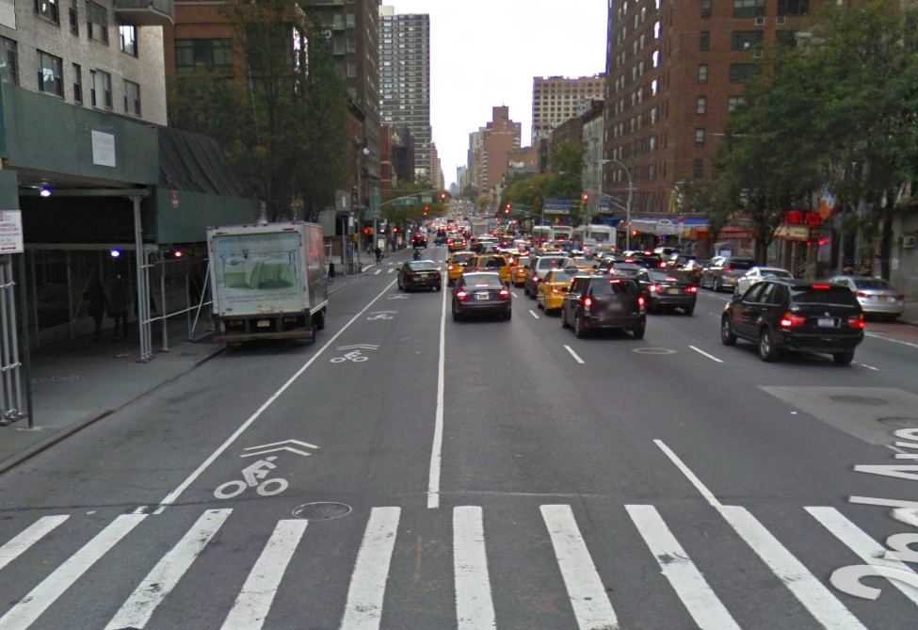

Type 2

Conventional bike lane
Carril de bicicletas/Carril-bici/Ciclovía
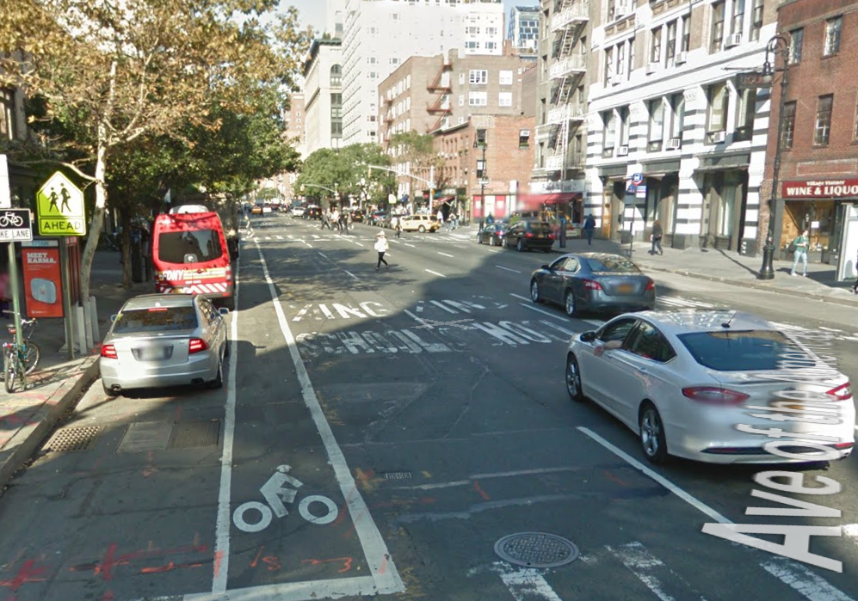

Type 3

Buffered bike lane
Carril de bicicletas protegido/Carril-bici protegido/Ciclovía protegida
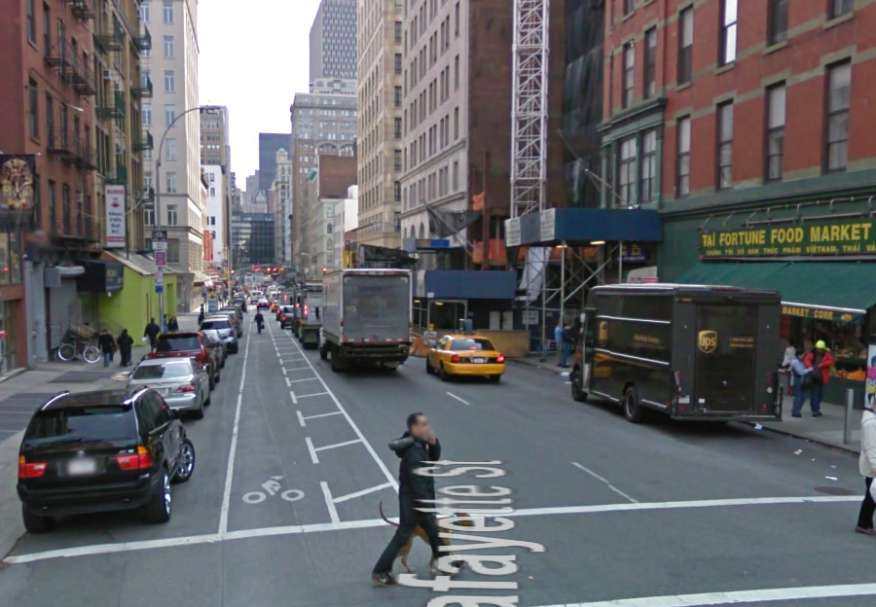

Type 4

Parking-protected bike lane
Carril de bicicletas protegido por carros estacionados/Ciclovía segregada con estacionamiento adyacente
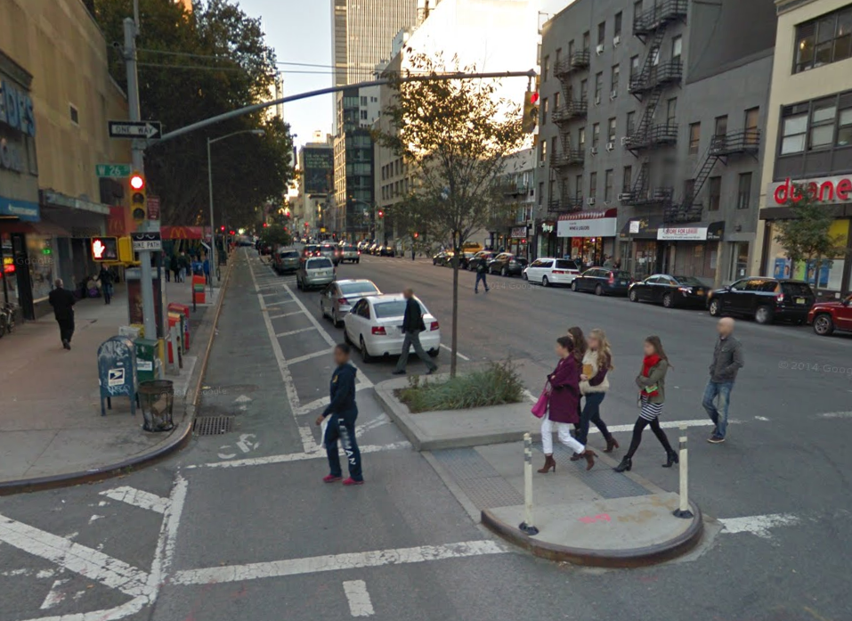

Type 5

Curb-protected bike lane
Carril de bicicletas protegido por guarniciones/Ciclovía segrada con guarnicíon
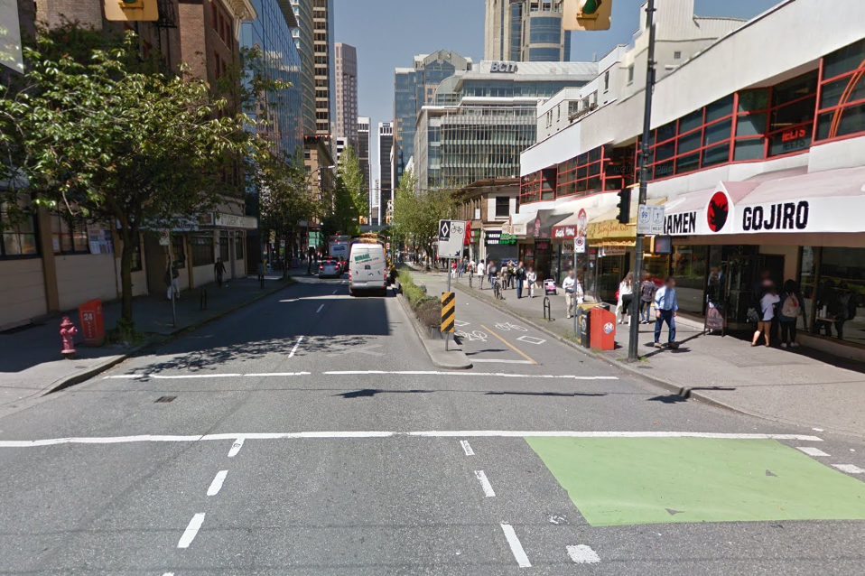

Type 6

Raised bike lane
Carril de bicicletas sobre acera/Acera-bici/Ciclovía segregada a través
de la elevación del pavimento
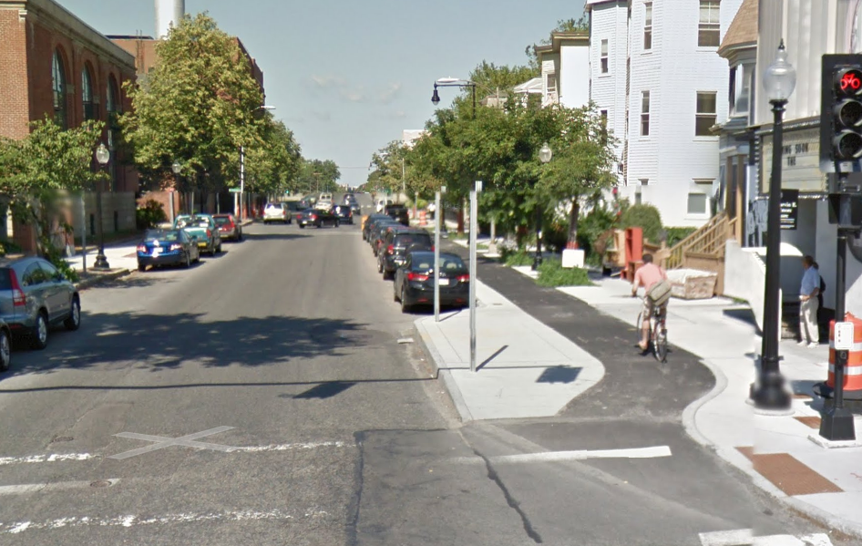

Adapted from work forthcoming by Portland State University
Adapted from work forthcoming from Portland State University

